ROYAL OAK INTERNATIONAL SCHOOL
SR. SEC. C.B.S.E. AFFILIATED (2019-20)
WHOLE YEAR SYLLABUS OF CLASS I

SUBJECT-ENGLISH

MONTH | NO. OF WORKING DAYS | CONTENT | ACTIVITY | VOCABULARY | WORKSHEET
April | 18 | *Recapitulation (from K.G.)  *Phonic Sounds  *Cursive writing Aa to Zz  MCB  Ch -1 : At the Beach  *Poem : Family is Special  Grammar: Vowels and consonants, Articles (a/an)  Writing : Myself | Draw a hand with a vowel | * Short /a/ sounds
May | 8 | MCB  * Poem : First Day at School  Grammar : Thealphabets | * Group activity Alphabetical order | * Compound words (Joined words) | * Worksheet  As per syllabus covered
July | 24 | MCB  CH-2 : A Fun Day at School  Grammar : Naming words,Punctuation  Writing: My School | * Popsicle activity(Nouns) (naming words) | * Short /i/ sounds | *Revision Worksheet  *RECAP TEST (M.M.-10)
Written Evaluation Syllabus: PAI(July) M.M.:- ( 30)
MCB
CH-1 : My Family
*Poem : Family is Special *Poem : First Day at School
Grammar : Articles, Vowels and consonants, Thealphabet
Writing : Myself
Aug. | 25 | MCB  Ch- 3 : The Sky is Falling  * Poem – The Little Chick  Grammar :Use of has /have, Pronoun  Writing : My Classroom(Describing things /places) | *Paste the pictures of 5 animals and write their sounds | * Rhyming words  * Short /e/ sounds  * short /o/ sound | * Worksheet  As per syllabus covered
Sept. | 4 | MCB  Ch-4 : Sundays are Fundays  Ch-5 : Goldilocks and the three bears (only reading)  * Poem – A Family Finger Play  Grammar :One and many | * Poem recitation with (finger puppet) props |  | *Revision Worksheet  *RECAP TEST (M.M.-10)
Written Evaluation Syllabus: Half-Yearly Exam(September) MM:-(60)
MCB
CH-2 : A Fun Day at SchoolCh- 3 : The Sky is Falling
* Poem – The Little Chick * Poem – A Family Finger Play
Grammar : Use of has /have, Pronouns , One and many, Naming words
Oct. | 17 | MCB  Ch-7 : Three Little Lambs  Ch-6: The noisy visitor (only reading)  * Poem – Welcome Home  Grammar : Use of is/am/are, Joining words,  Writing : Few lines about ‘My Home’ | *Poem Recitation with props | * Short /u/ sounds  * Long /o/ Sounds | * Worksheet  As per syllabus covered
Nov. | 9 | MCB  Ch-8 : School Picnic  * Poem – Ants at a Picnic  Grammar : Doing words, Gender  Writing : Sequencing sentences | * Do’s and Don’ts while you are alone at home | * long /a/ sound  * Long /i/ Sounds | *Revision Worksheet  *RECAP TEST (M.M.-10)
Written Evaluation Syllabus: PA-II(November)M.M:-(30)
MCB
Ch-7 : Three Little Lambs Ch-8 : School Picnic
Ch-4 : Sundays are Fun days
* Poem – Welcome Home * Poem – Ants at a Picnic
Grammar : Use of is/am/are, Joining words, Doing words, Gender,
Writing : Few lines about ‘My Home’, Sequencing sentences
Dec. | 20 | MCB  Ch-9 : The EnormousTurnip  * Poem – Vegetables  Grammar : Opposite, Describing words  Writing : My favourite Toy(Describing things) | *Show & Tell Activity | *Long /e/ sound | * Worksheet  As per syllabus covered
Jan | 19 | MCB  Ch-10 : Drippy and Drizzly  * Poem – Raindrops  Grammar : Position words, Adverbs, Use of has /have  Writing: Sequence sentences | *Make a word ladder using double letter words.( on A3 sheet ) | * Double letter word | *Revision Worksheet  *RECAP TEST (M.M.-10)
Feb | 6 | Revision
Written Evaluation Syllabus: Yearly Exam(February) M.M:-(60)
MCB
Ch-9 : The Enormous Turnip Ch-10 : Drippy and Drizzly
* Poem – Vegetables * Poem – Raindrops
Grammar : Opposite, Adverbs, Position words, Use of has/have, Describing words
Writing: My favourite Toy/My school bag , Sequence sentences

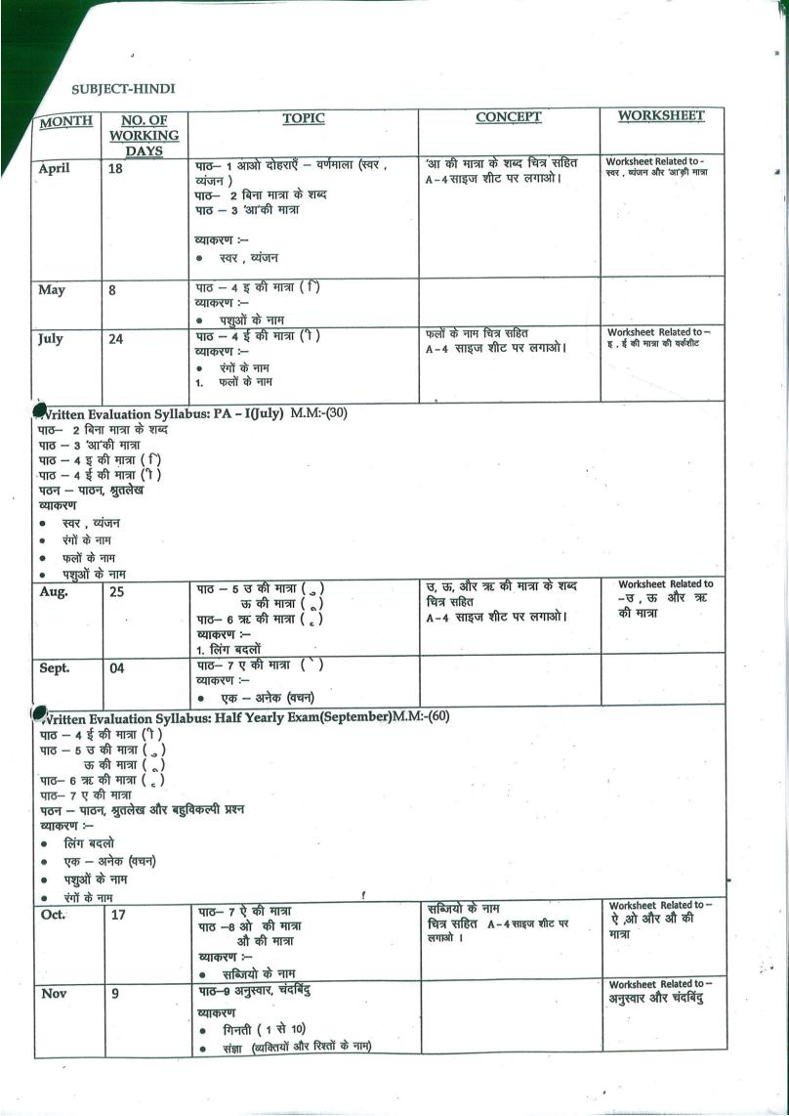
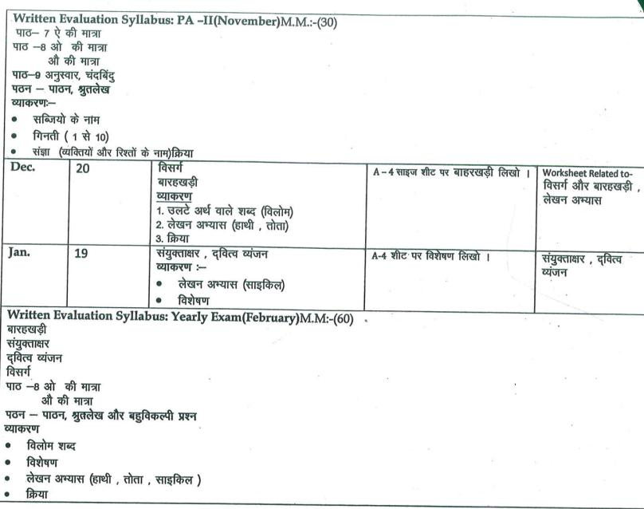

SUBJECT-MATH

MONTH | NO. OF WORKING DAYS | TOPIC | CONCEPT | ACTIVITY | WRORKSHEET
Apr. | 18 | Ch-1 Learning basics  Ch-2 Numbers from 1 to 10 , Counting 1 to 100, Number names 1 to 10  Ch-3 Addition | - Ordering and Comparing Numbers  - Addition by counting. | - Factastic Train  - Use of flash cards  - Using Floral petals for additioon | Ch-2 & 3
May | 8 | Ch-4 Subtraction | - Subtraction without borrowing | - Taking away activity through toffees and blocks | Ch-4
Jul. | 24 | Ch-5 Concept of Zero  Ch-9 Numerals on Abacus | - Addition property & subtraction property of zero based on addition  - 1-digit & 2-digit numbers concept and numbers in short form | - Use of Factastic train to teach properties of zero  - Using Abacus
Written Evaluation Syllabus: PA-I(July) MM(30)
Ch-1 Learning basics
Ch-2 Numbers from 1 to 10
Ch-3 Addition
Ch-4 Subtraction
Ch-5 Concept of Zero
Ch-9 Numerals on Abacus
Dodging tables 2 to 5
Aug. | 25 | Ch-6 Numbers from 11 to 20  Ch-7 Numbers from 21 to 50  Ch-15 Multiplication  Ch-10 Comparison of Numbers | - Number names, addition of smaller numbers.  - Multiplication using multiplication tables | - Using Ganitmala to show tables  - Crocodile mouth activity | Ch-6 , 7, 15
Sep. | 4 | Ch-20 Measurements  Ch-22 Spatial Relation | - Introduction of longer-shorter, big-small, heavy-light etc. | - Paste pictures showing concepts of short and tall ,big and small, heavy and light | Ch-20
Written Evaluation Syllabus: Half yearly Exam(September) MM(60)
Ch-6 Numbers from 11 to 20
Ch-7 Numbers from 21 to 50
Ch-10 Comparison of Numbers
Ch-15 Multiplication
Ch-20 Measurements
Ch-22 Spatial Relation
Dodging tables 2 to 7
Oct. | 17 | Ch-12 Addition of 2 digit numbers  Ch-13 Subtraction of 2 digit numbers  Ch-16 Ordinal numbers | - Addition by short method  - Subtraction by short method | - Use of blocks  - Position chart | Worksheet of ch-12, 13 & 16
Nov. | 9 | Ch-8 Numbers from 51 to 100  Ch-11 Ordering of Numbers  Ch-14 Skip Counting | - Counting by grouping, counting breaks | - Number chart  - Ganitmala | Worksheet of ch-8,11
Written Evaluation Syllabus: PA-II(November) MM(30)
Ch-8 Numbers from 51 to 100
Ch-11 Ordering of Numbers
Ch-12 Addition of 2 digit numbers
Ch-13 Subtraction of 2 digit numbers
Ch-14 Skip Counting
Ch-16 Ordinal numbers
*Dodging tables 2 to 10
Dec. | 20 | Ch-17 Time  Ch-18 Calendar  Ch-21 Shapes | - Parts of days, day & night  - Days & month  - Shapes & its types | Use of clock & calendar  Shapes-solid & plane | Worksheet of ch-17, 18, 21
Jan. | 19 | Ch-19 Money  Ch-23 Pattern | - Introduction of currency & adding money  - Sequence of objects | - Use of currency chart  - Use of different shaped blocks | Worksheet of ch-19, 23
Written Evaluation Syllabus: Yearly Exam(February)MM(60)
Ch-12 Addition of 2 digit numbers
Ch-13 Subtraction of 2 digit numbers
Ch-17 Time
Ch-18 Calendar
Ch-19 Money
Ch-21 Shapes
Ch-23 Pattern
*Dodging tables 2 to 10

SUBJECT-EVS
MONTH | NO OF WORKING DAYS |  | TOPIC | CONCEPT | ACTIVITY | WOKSHEET
April | 18 |  | Ch1- Myself  Ch 2- My body | 1.Showing picture of different parts of body and their work. | 1.Learn and write their name ,class,and telephone number.  2.Write and paste the picture of any 5 parts of the body in A-4 size sheet. | Ch-1 and Ch- 2
May | 8 |  | Ch3- My sense organ | 1.Showing the function of sense organs with help of students | Do the activity given on page no. 18.
July | 24 |  | Ch4- My family  Ch5- My Houses and School  Ch6- My food Habits | 1.Dicussion on family and how we help one another in family  2. Showing different types of Houses  3.Visiting different rooms in our school  4. Showing real food we get from plants and animals. | 1.Paste a picture of your family on A-3 sheet and write 3 sentences on it.  2.Do the activity given on page no 43. | Ch-3 and Ch- 4
Written Evaluation Syllabus: PA –I(July) MM(30)
Ch1- Myself
Ch 2- My body
Ch3- My sense organ
Ch4- My family
Aug. |  | 25 | Ch 7 – Keeping Healthy and Safe  Ch 8 – Good Manners | 1. Enactment of Do’s and Don’t’s in School and Home.  2. Enactment of good manners and habit in the class. | . | Ch-7 and Ch- 8
Sep. |  | 4 | Revision |  |  | Recapitulation worksheet
Written Evaluation Syllabus: Half Yearly Exam(September) MM(60)
Ch 2- My body
Ch4- My family
Ch5- My Houses and School
Ch6- My food Habits
Ch 7 – Keeping Healthy and Safe
Ch 8 – Good Manners
Oct. |  | 17 | Ch 9 – Places of Worship and our Festivals  Ch 10 – People who Help us | Discussions about different type of festival and their values by showing pictures  Discussion about our helpers . | Collect pictures of any five helpers and write their work on A4 sheet | Ch-9 and Ch- 10
Nov. |  | 9 | Ch 11 – Our Nation  Ch 12 – Plants and Animals Around us | 1. Show Flash card of different types of animal  1. Playground visit to show different types of plants and trees. | 1. Collect any four national symbols  ( nationalbird,national animal etc.). Paste them on A4 sheet. | Ch-11 and Ch- 12
Written Evaluation Syllabus: PA II(November) MM(30)
Ch 8 – Good Manners
Ch 9 – Places of Worship and our Festivals
Ch 10 – People who Help us
Ch 11 – Our Nation
Ch 12 – Plants and Animals Around us
Dec. |  | 20 | Ch 13- Air and Water  Ch 14 – Seasons in India  Ch 15 – The Earth and the sky | 1. Discussion about uses of water and air.  2. Showing Globe to the student. | 1. Paste picture of different seasons on A- 4 sheet | Ch-13, Ch- 14 and 15
Jan. |  | 19 | Ch 16 – How do we Travels?  Ch 17 – Games we Play | 1. Showing Flash Card of different means of transport. | 1. Collect pictures of outside and inside game and paste them on A4 Sheet. | Ch-16 and Ch- 17
Feb. |  | 6 | Revision |  |  | Recapitulation worksheet
Written Evaluation Syllabus: Yearly Exam(February) MM(60)
Ch3- My sense organ
Ch 11 – Our Nation
Ch 12 – Plants and Animals Around us
Ch 13- Air and Water
Ch 14 – Seasons in India
Ch 15 – The Earth and the sky
Ch 16 – How do we Travels?
Ch 17 – Games we Play

SUBJECT-COMPUTER
MONTH | NO. OF WORKING DAYS | CONTENT |  | ACTIVITY | PRACTICAL | WORKSHEET
April | 18 | Ch – 1 : Know your computer |  | *Paste Natural things and God made things in your notebook. | * Basic introduction of computer | Ch-1&  Ch-2
May | 8 | Ch – 2 : Computer a smart machine |  | *Paste the picture of computer in notebook | *Notepad
July | 24 | Ch – 3 : Computer at work (Reading) |  | * Paste the places where computer are used. | * Notepad
Written Evaluation Syllabus: PA –I(July) MM(20)
Ch – 1 : Know your computer
Ch – 2 : Computer a smart machine
Practical: Notepad
Aug. | 25 | Ch – 3 : Computer at work (Exercise)  Ch – 4 : Parts of computer |  |  | * Notepad | Ch-3 & Ch-4
Sep. | 4 | Revision
Written Evaluation Syllabus: Half Yearly Exam(September) MM(30)
Ch – 3 : Computer at work
Ch – 4 : Parts of computer
Practical: Notepad
Oct. | 17 | Ch – 5 : Knowing the keyboard  Ch – 6 : Knowing the mouse(Reading) | * Draw the different keys of the keyboard |  | *Paint | Ch-5 & 6
Nov. | 9 | Ch – 6 : Knowing the mouse(Exercise) | * Draw and label different parts of mouse
Written Evaluation Syllabus: PA II(November) MM(20)
Ch – 5 : Knowing the keyboard
Ch – 6 : Knowing the mouse
Practical: Paint
Dec. | 20 | Ch – 7 : Let us draw | *Draw different tools of paint window in notebook. |  | *Paint | Ch-7 & 8
Jan. | 19 | Ch – 8 : Computer room manners | *Write four computer Room manners in notebook.
Feb. | 6 | Revision+ YEARLY EXAM
Written Evaluation Syllabus: Yearly Exam(February)MM:-30
Ch – 7 : Let us draw
Ch – 8 : Computer room manners
Practical: Paint

SUBJECT-DRAWING & ART/CRAFT
MONTH | NO. OF WORKING DAYS | PAGES OF ART BOOK | ACTIVITY
April | 18 | 3-6,21,22 | Hands print duck 21  Meal time – leaf impression 22
May | 8 | 7,8,33 | Mothers day card
July | 24 | 9,10,29,30,31,23 | My garden – wood 29  Ice cream dollaps – fevicol impression 30
Aug. | 25 | 11,12,27,32,34 | Flowers – pencil shaving 32
Sep. | 4 | Revision
Written Evaluation Syllabus: Half-Yearly Exam(September)
page no. 3 to page no.12
page no. 21 to page no. 23
page no. 27 to page no. 34
Oct. | 17 | 13,14,24,35,36 | Lion face 34  Bead the flowers 36
Nov. | 9 | 15,16,25,37,38 | Landscape – sand paper 37  Butterfly – stencil 25
Dec. | 20 | 17,18,26,28,39 | Daffodils, ice cream stick +thurmacol bolls  House – model
Jan. | 19 | 19,20,40 | Rainbow – paper collage
Feb. | 6 | Revision
Written Evaluation Syllabus: Yearly Exam(February)
page no.13 to page no. 20
page no. 24 to 26
page no. 35 to 40

SUBJECT-DANCE
Month | Number of Working Days | Topic
April | 18 | Foot, Shoulders, Hands, Neck, Waist movements
May | 8 | Foot, Shoulders, Hands, Neck, Waist movements
July | 24 | Aerobics and body stretching exercises  Body balancing movements
Aug. | 25 | Aerobics and body stretching exercises  Body balancing movements (Janmastmi Celebration)
Sep. | 4 | Free style dancing (Dussehra celebration)
Oct. | 17 | Free style dancing (Dussehra celebration)
Nov. | 9 | Western Dance (Christmas Celebration)
Dec. | 20 | Western Dance (Christmas Celebration)
Jan. | 19 | Patriotic dance (Republic day celebration)
Feb. | 6 | Patriotic dance (Republic day celebration)
- Presentation of houses activity

